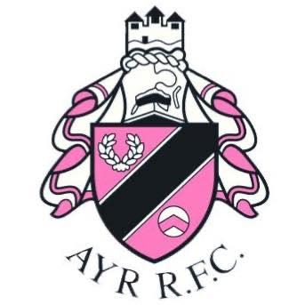

Ayr Rugby Football Club Limited
Board Director/Trustee
Application Form

Please refer to the accompanying notes before completing the application.

Name

Current Occupation

Previous Experience

Skills | Please indicate against each relevant area if this is your Principle skill, by writing ‘P’, or a Secondary skill where you have experience, by writing ‘S’.
Skills |  | P/S |  | P/S
Skills | Business Management |  | Grant Funding / Fund Raising
Skills | Financial / Accounting |  | Health
Skills | Legal / Law |  | Children & Young People
Skills | Marketing / P.R. |  | Cultural / Community
 | IT / Digital / Social Media |  | IP / Trademark experience
 | Human Resources |  | Other (specify below)

In your own words please outline your relevant experience, which area of expertise you believe you can contribute the most, and why you wish to become a Director/Trustee for Ayr Rugby Football Club.
(300 words maximum)

Are you, or have you been, a Trustee or Director of a Charity registered with OSCR. Please give
details below including dates, position and achievements. (100 words maximum)

Personal Contact Details
Home Address | Post Code
Telephone | Landline |  | Mobile
E-mail
Membership No.
Preferred means of contact

DATA PROTECTION CONSENT
In accordance with the General Data Protection Regulation (GDPR), the information provided on this form will be used in the recruitment and selection process. In accordance with the articles of association the information will be made available to the Directors/Trustees and, if subject to a vote at an AGM, an abbreviated version will be made available to the membership of Ayr Rugby Football Club Limited. It will also form the basis of the confidential personnel record of the successful candidate. In the case of unsuccessful candidates, the information will be destroyed after twelve months. In addition, it will be held on a database and used for equal opportunities monitoring purposes.

I agree that Ayr Rugby Football Club Limited has the right to validate any of the information provided.

DECLARATION OF ELIGIBILITY TO BECOME A CHARITABLE DIRECTOR/TRUSTEE

I declare that I am not disqualified from acting as a charity trustee and that (please tick below to confirm and agree each statement):

- I am not incapable of acting by reason of mental disorder within the meaning of the Mental Health Act 1983.
- I do not have an unspent conviction relating to any offence involving deception or dishonesty. Because of the nature of the role you are applying for, you are required by the Rehabilitation of Offenders Act 1974 to declare all criminal convictions including those which are ‘spent.’ Please detail therefore any such convictions in the space below
- I am not an undischarged bankrupt, nor have I made a composition or arrangement with, or granted a trust deed for, my creditors.
- I am not subject to a disqualification order under the Company Directors Disqualification Act 1986, or to an order made under section 429(b) of the Insolvency Act 1986.
- I have not been removed from the office of charity trustee or trustee for a charity by an Order made by the Charity Commissioners or the High Court on the grounds of any misconduct or mismanagement, nor am I subject to an order under section 7 of the Law Reform (Miscellaneous Provisions) (Scotland) Act 1990, preventing me from being concerned in the management or control of any relevant organisation or body.
- I am not subject to a disqualification order under the Criminal Justice and Court Services Act 2000.
- I am not disqualified under the Protection of Vulnerable Adults List.

The information supplied in this application form is true and accurate to the best of my knowledge.

If your application is successful and you accept the role of Director/Trustee you may be asked to apply for a Disclosure Scotland check.

I have read and understand the supporting notes describing the duties/roles of a Director/Trustee of Ayr Rugby Football Club.

Tick here

Signed ………………………………………………………………………………….

Date ……………………………………

Applications must be submitted by Wednesday, 11th September 2024 at 12 noon. Please email the completed application to: trustees@ayrrugbyclub.co.uk

Form updated August 2024

Ayr Rugby Football Club Limited, Millbrae, Alloway, Ayr, KA74PJ, Registered charity, SC051905

